Design Document

Team Name : String Cheese

Team Members :

Chris Schaffer, Meetkumar Savaliya, Tim Stroup, Wei Chen, Ya-Hsin Cheng (List alphabetically)

Package Diagram :

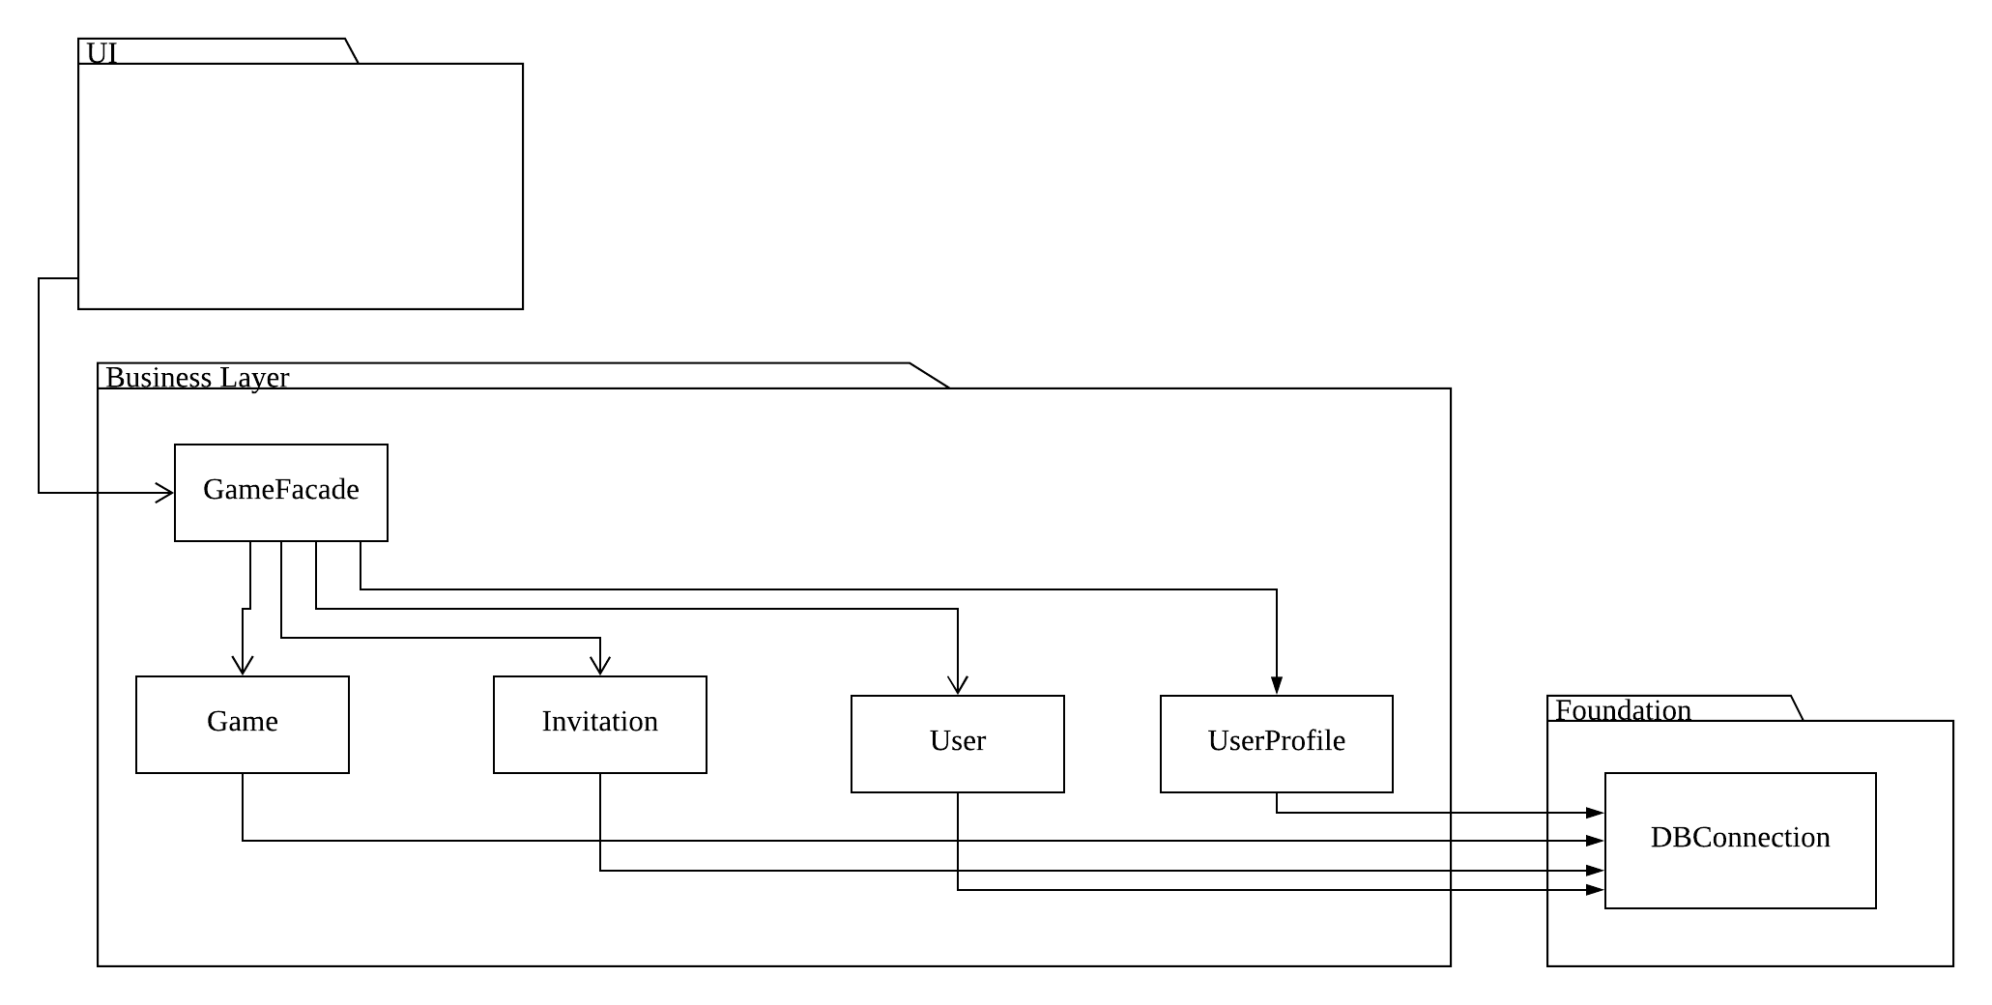

Class Diagram : Game

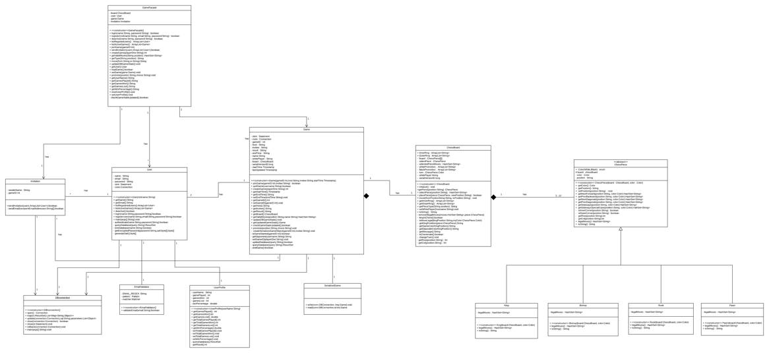

Class Diagram : UI Interface

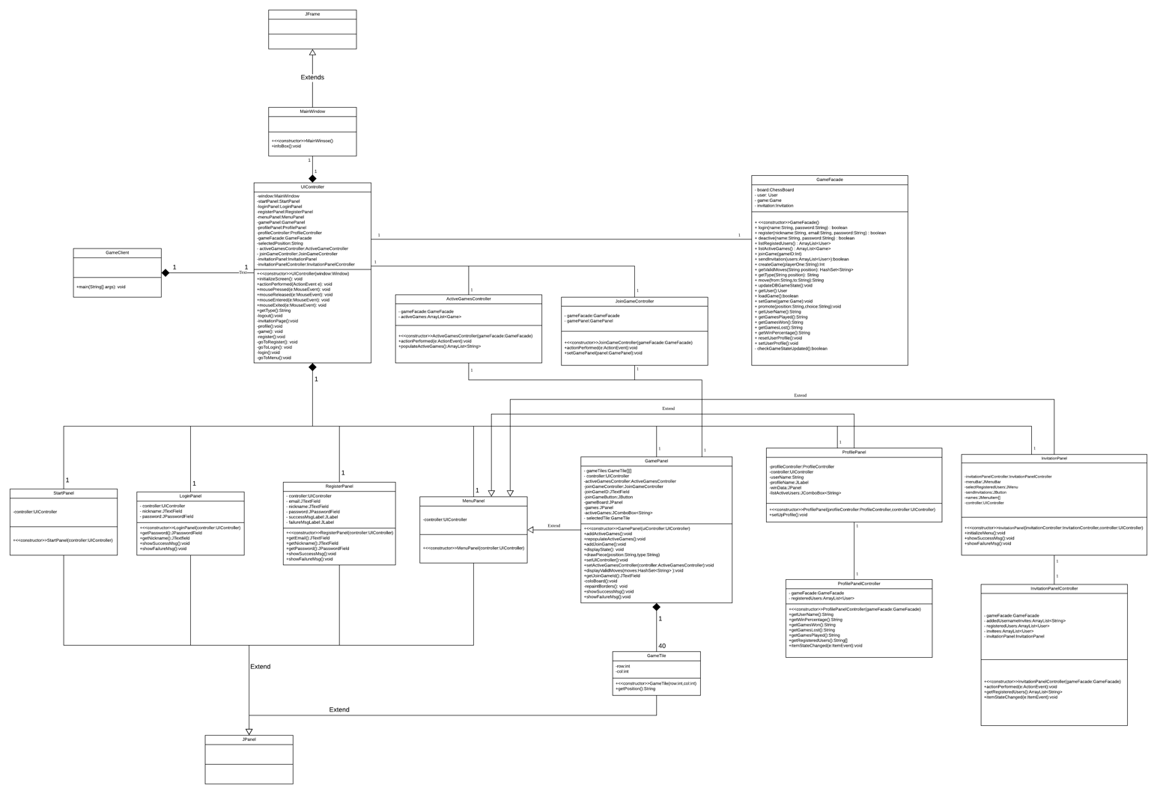

Sequence Diagrams :

* Display Valid Moves

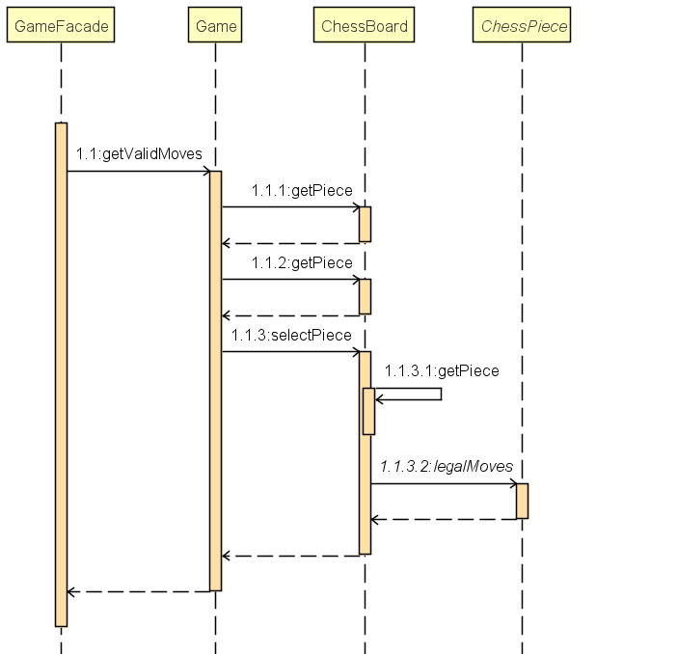

* Join Game

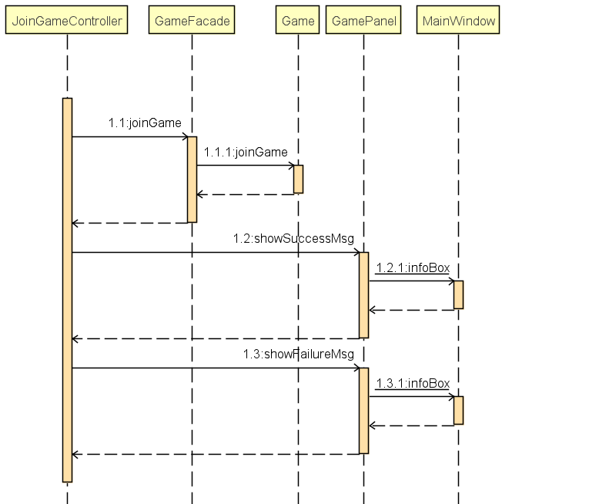

* Make Move

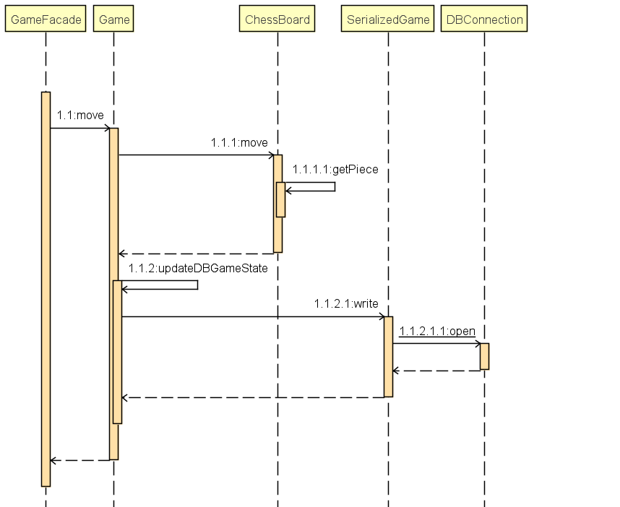

* Send Invitations

